Why the MLB is the Best Professional Sports League

In a previous post, I ended the argument to why baseball is the greatest sport. In today’s post, I will discuss that not only is baseball the greatest sport, but Major League Baseball is also the best professional sports league (of the same three most popular American sports: football, basketball, and baseball). This is on the basis of league scheduling and playoffs – the two things that really differentiate leagues in the first place (besides the sport itself obviously).

**League alignment actually matters**

The MLB, NFL, and NBA all have a division and conference alignment of their teams. Each has two conferences with either three or four divisions in each conference. There have been talks recently of eliminating conferences and divisions in the NBA because of the imbalance of power. The reason why divisions and conferences exist is to determine seeding in the playoffs. However, of the three sports baseball’s division alignment makes the most sense, while the NBA’s is basically irrelevant. The way the MLB designs its schedule makes the divisions actually matter. Division winners in all three sports get an automatic top seed in the playoffs. The premise of the playoff format is that the best teams in each division (plus the best of the rest) play each other to determine who is the best in their conference. Then the best team in each conference plays the other to determine the champion. So winning a division should mean that team is the best in the division *compared to the others*. Let me explain with a chart:

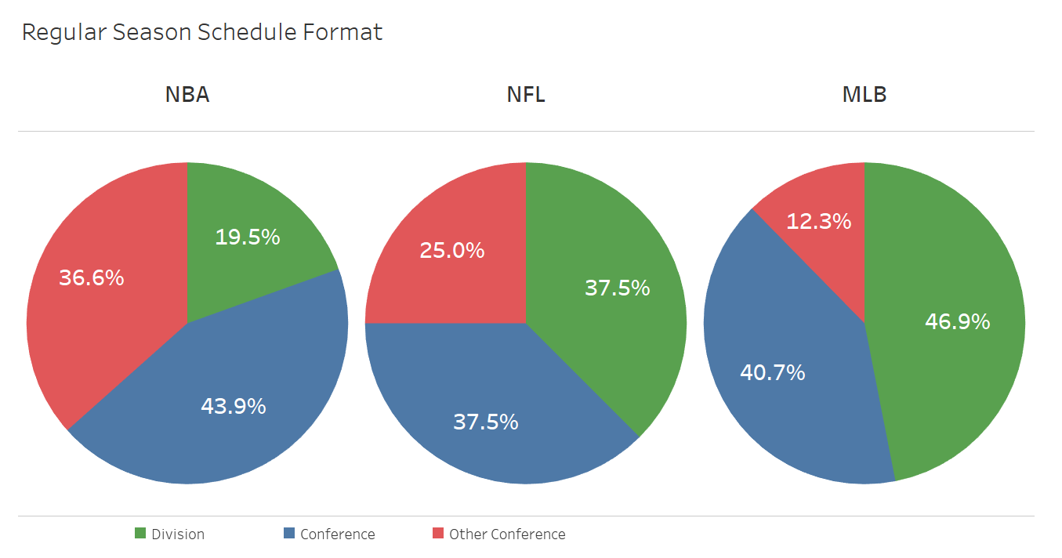

Each sport designs its schedule so that each team in every division plays the same teams throughout the year. However of the three sports, the MLB has the highest percentage of total games played against teams *within* the division (46.9%) while the NBA only has a measly 19.5%, less than one-fifth of the games. This means that in the MLB, more of a team’s records reflects head-to-head games against teams within their division. So the team that has the best record at the end of the season has a larger proportion of its record determined by a direct comparison to its division. Thus baseball gives the most meaning to the premise of a “division winner,” while in basketball only makes division opponents slightly more important than everyone else.

Similarly, the MLB has the lowest percentage of games played against the other conference (in baseball it’s called a “league”) with just over 12%, while the NBA is highest at 36.6%. This creates a truer separation between the two leagues in baseball, as the vast majority of games played are against a team’s own league. Therefore, in the World Series the teams who face off to crown a champion really are “the best team in their league” as they have proven throughout the season and playoffs that they are consistently better than the other teams in their league. On the other hand, maybe it does make sense to throw away divisions and conferences in the NBA and seed everyone just 1-16 since their schedule is the most balanced, playing everyone in the NBA relatively equally compared to both the MLB and NFL.

Across both of the previous discussions, the NFL ranks between the MLB and NBA.

**Playoffs are the most competitive**

Not only does the regular season make the most sense, but in baseball the playoffs are the most competitive and worth watching. Again, basketball is the most pointless, and football has its issues too. In football, because of the nature of the game, each playoff round is a single game. On a given day, any team could win, so there is a good deal of chance that is inherent in the NFL playoffs. Let’s take a look at a bunch more graphics to help me paint this picture. The following graphs show the distribution of champions:

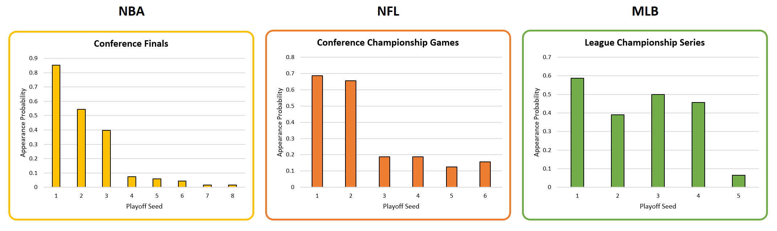

All stats are taken from the first year of the current playoff structure for each sport. I know there’s a lot to look at. Let me help focus you on some important points to notice. The MLB has the most even distributions for both measures, with the league championship round more or less being equally likely for seeds #1-4. On the other hand, the NFL championship games lean heavily toward #1 and #2 with teams seeded #3-6 having a less than 20% chance of making the championship game. Furthermore, the NBA is a joke with predominantly #1-3 seeds having more than a prayer to make the conference championship game (20% for all other seeds combined). Now let’s look at the chances of making the conference finals by seed for each sport:

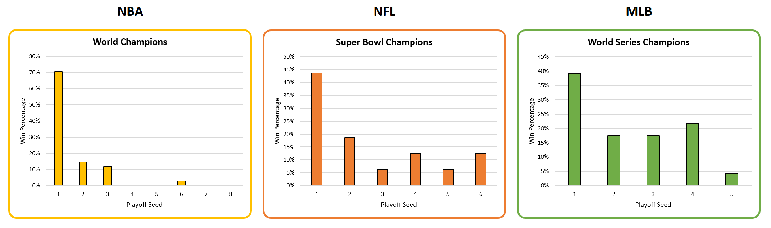

In terms of champions, greater than 70%(!) of the time a #1 seed wins the NBA championship, and >97% of the time a #1-3 seed wins it all. Basically, if you’re not a top-3 seed you have no real hope of being NBA champion. In case you’re wondering, the only non-top-3 seed to win was the 1994-95 Houston Rockets who were a #6 seed…but also had two Hall of Famers in Clyde Drexler and Hakeem Olajuwon. The NFL is slightly more interesting with a #4 and #6 seed having won twice each. But the numbers are still skewed heavily toward the top-2 seeds, with all others winning only a little better than landing heads on a three-sided coin. When we look at the MLB, the baseball champion is actually more likely to be a #4 seed than a #2 or #3 seed.

What this tangibly means is that baseball playoffs are the most competitive among all the teams that make the playoffs, and that making the playoffs (sans the #5 seed which was only introduced in 2012) gives you a decently good chance of winning it all. Comparatively, the NFL is slightly worse, but skewed toward the #1 and #2 seeds who get a first round bye, and the NBA should really think about reducing the number of playoff teams from eight to four. I mean, c’mon, the NBA playoffs take forever and the end result is the same without #5-8.

**Conclusion**

Baseball is the greatest sport. Hitting a round baseball with a round bat has been called the most difficult thing to do in sports. A hitter has about a quarter of a second to identify a pitch type, determine its location, and figure out whether to swing. Fast-twitch reactions, speed, and power are necessary to play the game at a high level. The division and league alignments have real meaning through the scheduling of games. The playoffs are the most competitive, giving every team a tangible chance of becoming champion. Baseball is not a game that requires elite genes to reach the upper echelon of the sport, and it encourages teamwork more than other sports. Oh, and that’s just scratching the surface…